NATIONAL INSTRUMENT DATABASE · NSF SRI LANKA
Technician Quick Guide
Register → Complete Your Technical Profile → Get Approved → Start Working
A step-by-step guide for technicians who want to register on the National Instrument Database, build a complete technical profile, obtain approval, and start receiving service requests from instrument owners across the country.
1 Register2 Verify Email3 Sign In4 Technical Profile5 Supervisor Consent6 Approval7 Accept Jobs

Contact System Administrator: +94 (0)11 2 696771 · Ext: 191, 126 · nid@nsf.gov.lk

Contents
1. Before You Start — What You Need
2. The Journey at a Glance
3. Step 1 — Register as a Technician
4. Step 2 — Verify Your Email (OTP)
5. Step 3 — Sign In to Your Account
6. Step 4 — Complete the Technical Profile
4.1 Personal Information 4.5 Certificates
4.2 Technical Expertise 4.6 Related Work Experience
4.3 Areas of Technical Expertise 4.7 Terms and Conditions
4.4 Current / Past Employment
7. Step 5 — Supervisor Confirmation
8. Step 6 — Get Approved
9. Step 7 — Start Working on Requests
10. Troubleshooting & Common Errors
11. One-Page Final Checklist

1. Before You Start — What You Need
The whole process is one continuous journey. Nothing is optional except where noted, and you cannot skip ahead — the system will not send your profile for review until every required section is complete and all four Terms and Conditions are accepted.
Group | What to have ready
Identity & Contact | Valid NIC number (9 digits + V/X, or 12 digits)  Mobile number — 10 digits starting with 0  Email address you can open (needed for the OTP and the supervisor invite)  Password — minimum 6 characters  Title (Mr / Mrs / Miss) and Name with Initials  Residential address and district  A clear passport-size photo (optional)
Institute & Supervisor | Your institute name — picked from the system list, it is searchable and not free text  Your designation at that institute  Supervisor name and designation  Supervisor email address  Supervisor contact number — 10 digits starting with 0
Professional Evidence | Technical expertise: the laboratory categories, instrument categories, instruments and care categories you actually work with  At least one employment entry — organization, position, start date  At least one certificate — name and number, ideally the scanned file  Related work history (optional but strongly recommended)

Heads-up on the supervisor step
If you answer Yes to “Do you have a supervisor?”, your profile will not be approvable until that supervisor opens the emailed link and records consent. This is the single most common reason a technician appears stuck. See Step 5.

2. The Journey at a Glance
Register & Verify  Account created, 6-digit OTP | → | Build Profile  Seven sections, then Submit | → | Supervisor Consent  Only if a supervisor is declared | → | Approval & Go Live  Administrator reviews your profile

Your account status moves through four values. This single value controls what you can and cannot do in the system, and it is the fastest way to understand where you are.
Status | What it means | What you see in the sidebar
PENDING | Account created, but the profile has not been submitted yet. | Red badge —  Not Approved
SUBMITTED | All four Terms and Conditions accepted. Your profile is now in the review queue. | Red badge —  Not Approved  (until the admin acts)
APPROVED | Administrator has approved you. Service requests can be accepted. | Green badge —  Approved
DECLINED | Administrator has declined the profile. Fix the details and re-submit. | Red badge —  Not Approved

3. Step 1 — Register as a Technician
Open the technician sign-in page and click Register as Technician on the login screen — the link under the login form, or the technician banner button. You land on the Technician Registration page, which asks for six fields in two blocks.
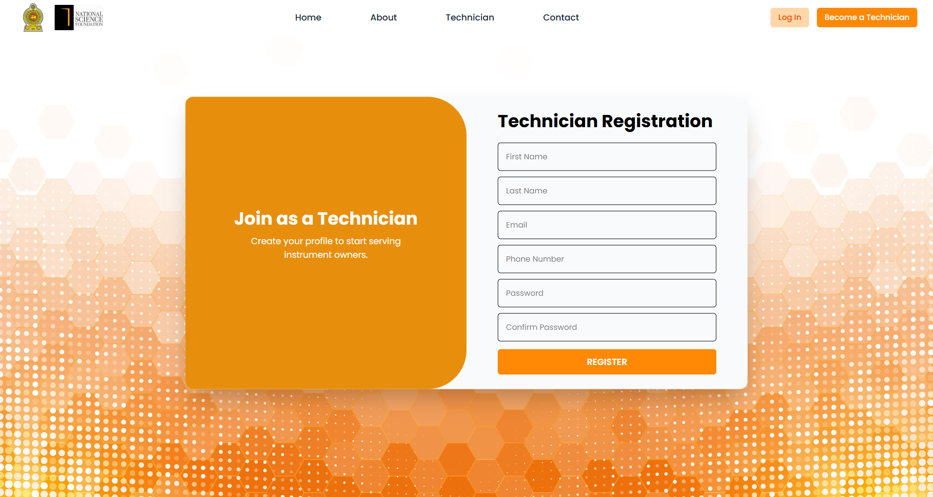
Figure 1 — The Technician Registration page, reached from the technician sign-in screen.
Field | Required | Notes
First Name * | Required | Section 1 — Personal Information. Enter your first name.
Last Name * | Required | Section 1 — Personal Information. Enter your last name.
Mobile Number * | Required | Section 1 — Personal Information.  10 digits, e.g. 0771234567.
Email Address (User Name) * | Required | Section 2 — Account Credentials. Format name@example.com.  This is also your login user name and the address that receives the verification code.
Password * | Required | Section 2 — Account Credentials. Minimum 6 characters.  Use the eye icon to reveal what you typed.
Confirm Password * | Required | Section 2 — Account Credentials. Must match the password exactly.

Click the orange Register Account button. On success a message appears saying the OTP has been sent, and you are taken straight to the email verification screen.
Already registered?
If the email is already in the system you will see an error under the Email field. Use Sign In here at the bottom of the page instead, or reset the password via Forgot Password on the login screen.

4. Step 2 — Verify Your Email (OTP)
Immediately after registration, a 6-digit verification code is emailed to the address you just entered. The verification screen shows the target address so you can confirm you are on the right account.
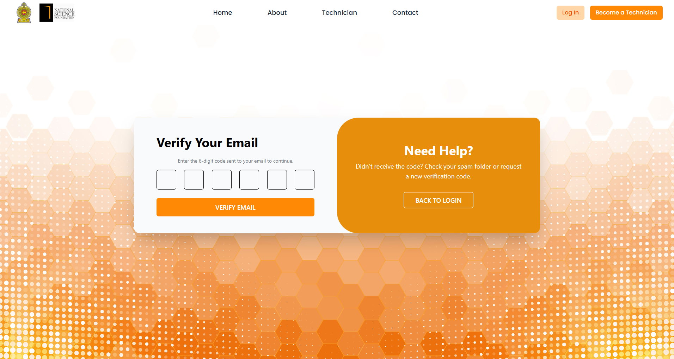
Figure 2 — Email verification. Enter the six digits, then press Verify Email.
- Type or paste the code into the six boxes. The cursor moves to the next box automatically as you type.
- Press Verify Email. A success message appears and you are returned to the sign-in page.
- No code? Check the spam or junk folder, then press Resend Code for a fresh one.
Messages you may see
“Please enter all 6 digits!” — the boxes are not all filled in.
“Invalid OTP. Please try again!” — the code is wrong or has expired. Resend it.
“A new verification code has been sent to your email.” — the resend worked; check the newest email.

Tip
Always use the most recent code. When you press Resend Code, the older code stops working.

5. Step 3 — Sign In to Your Account
Now sign in with the email and password you just created. Technician accounts land directly on the Technician Dashboard. The left sidebar becomes your main navigation and shows your current approval status at the top.
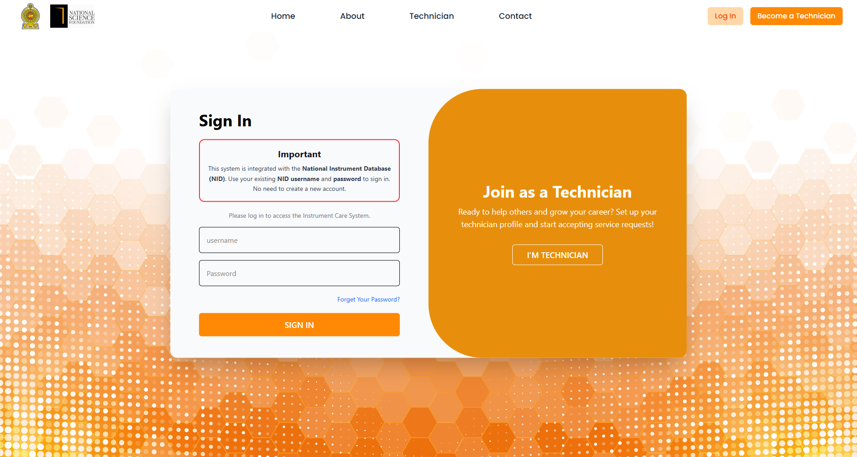
Figure 3 — The technician sign-in page.
Sidebar Navigation | Status Badge
Dashboard  — your overview and statistics  Service Request  — requests matched to your expertise  My Profile  — the technical profile form | APPROVED  (green) — you are live  NOT APPROVED  (red) — profile not yet approved  Awaiting Supervisor Confirmation  (amber) — see Step 5

Forgotten password?
On the login screen choose Forgot Password, enter your email address, and the system sends a reset link. Follow the link to set a new password, then sign in again. The same screens are used if you are redirected there to set an initial password.

6. Step 4 — Complete the Technical Profile
From the sidebar choose My Profile. This is a single long form titled Technician Profile containing seven sections, with a single Submit Profile button at the very bottom. Every section validates independently, so you can work through them in any order — but all of them must pass before anything is saved.
How the form reports problems
When you press Submit Profile with something missing, a red summary box appears at the top of the page listing the offending sections. Each section name is a link — click it to jump straight there. Any section with a problem also gets a red Needs attention badge in its header. Nothing is saved until every section is valid, so fix the list and press Submit Profile again.

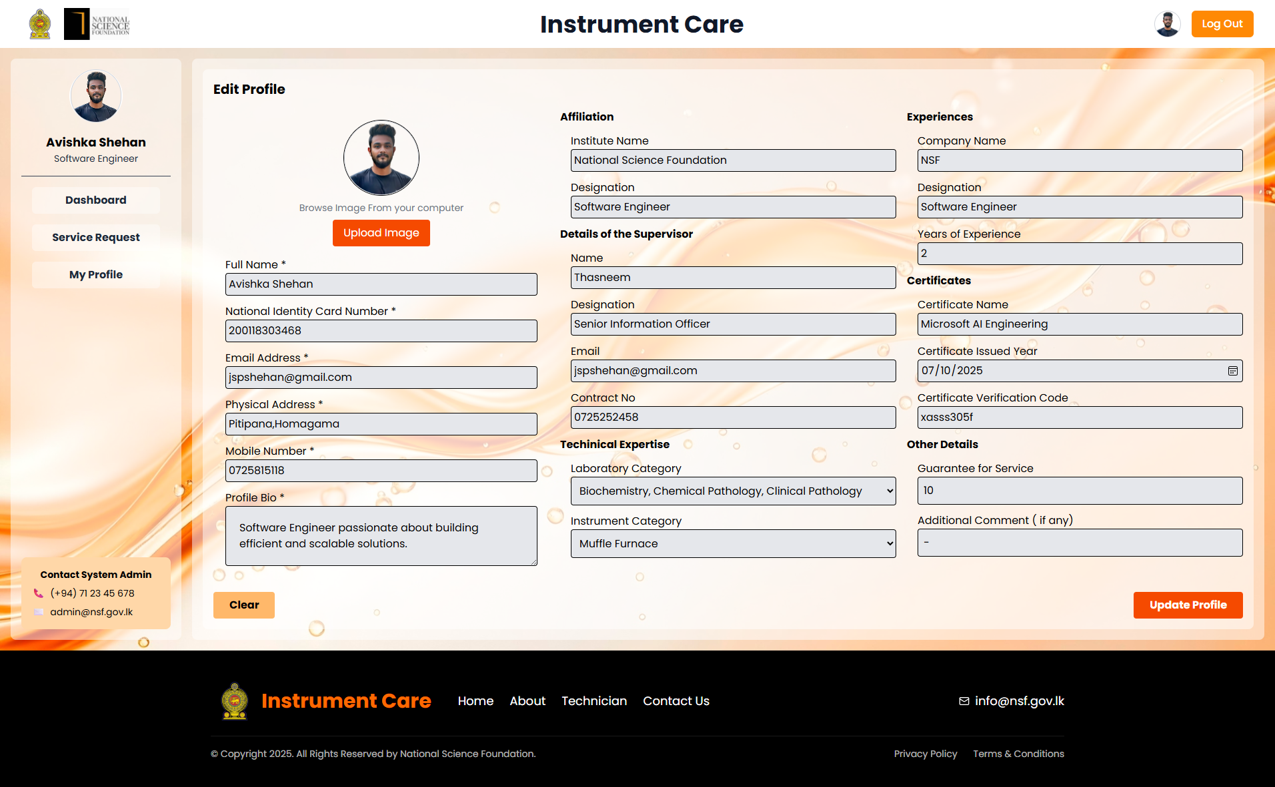
Figure 4 — The Technician Profile page. Scroll through all seven sections, then use Submit Profile at the bottom.

4.1 Personal Information (required)
Field | Required | Notes
Profile image | Optional | Choose File button; any image format.
Title * | Required | Mr / Mrs / Miss.
Name with Initials * | Required | Format N.M.Perera.
Full Name | Auto | Filled in from your registration and locked — not editable.
NIC Number * | Required | 9 digits followed by V or X, or 12 digits.
Gender * | Required | Male / Female.
Address * | Required | Your residential address.
District * | Required | One of the 25 Sri Lankan districts (Colombo, Gampaha, Kandy, Galle, Jaffna, Matara, …).
Mobile Phone * | Required | 10 digits starting with 0, e.g. 0771234567.
Land Line Phone | Optional | Office number, if you have one.
Email | Auto | Taken from your verified registration and locked.

Institute Details
Answer Do you belong to an institute? — Yes or No.
Field | Required | Notes
Institute Name * | If Yes | Start typing and a suggestion list appears. You must click one of the suggestions; typing a name by hand is rejected with “Please select an institute from the suggestions”.
Designation * | If Yes | Your job title at that institute.

Choosing “No” clears the section
Switching Do you belong to an institute? to No automatically clears the institute, designation and all supervisor fields, and removes the supervisor consent requirement. Set this before you save if you are an independent technician.

Supervisor Details
Only shown when you answered Yes to the institute question. Then answer Do you have a supervisor?
Field | Required | Notes
Supervisor Name * | If Yes | Full name of your supervisor.
Supervisor Designation * | If Yes | Their job title.
Supervisor Email * | If Yes | Must be a valid address — the consent invitation is sent here.
Supervisor Contact Number * | If Yes | 10 digits starting with 0.

When you submit, the system emails the supervisor an invitation automatically. An amber panel appears saying the invitation has been sent, with the recipient address and Status: Pending, plus a Resend Invitation button. Once they consent, the panel turns green and reads “Your supervisor has confirmed and provided consent.”

4.2 Technical Expertise (required — at least one entry)
This is the section that decides which service requests you are matched to. It is made of five sub-lists. Each dropdown is searchable, and each has an Other choice that reveals a text box so you can type a value that is not in the system list.
Sub-list | How to fill it
Laboratory Categories | Use Add Laboratory Category to add a row, then pick from the searchable dropdown (or choose Other and type your own). Use Remove to delete a row. Saved values display as orange tags.
Instrument Categories | Same pattern — Add Instrument Category, searchable dropdown, optional custom entry, and Remove per row.
Instruments | The specific instruments you service. The list is very large, so use the search box inside the dropdown. Added one row at a time.
Instrument Care Categories | The type of care you provide (for example calibration, preventive maintenance, installation). Added with Add Instrument Care Category.
Manual / Unlisted Instruments | For instruments that are not in the system at all. Type the name (for example Custom Centrifuge Model X) and press Add Manual Override. Each one appears as a removable blue tag.

Be specific — it pays off
The more accurate these lists are, the better the service requests you are matched to. Add every category and instrument you genuinely work on. If you edit a saved entry and leave the editor open, the form will refuse to submit until you press Save or Cancel.

4.3 Areas of Technical Expertise (required)
Two checkbox groups. You must select at least one option in each.
Group | Options
Service Coverage | “Please indicate the region(s) you provide service coverage for”  Island-wide · Western · Central · Southern · Northern · Eastern · North Western · North Central · Uva · Sabaragamuwa · Other (Specify)
Availability | “Please indicate your availability”  Full-time Technical Service Provider · Part-time Technical Service Provider · Contractual Basis · Consultancy Basis · Emergency Support Available · Other (Specify)

If you tick Other (Specify), a text box appears and you must type what it means — otherwise the section will report “please specify the ‘Other’ value”.

4.4 Current / Past Employment (required — at least one entry)
Field | Required | Notes
Organization * | Required | Employer or institution name.
Position / Role * | Required | Your job title.
Start Date * | Required | Pick from the date picker.
End Date | Optional | Leave blank if this is your current job. The system then counts the role as ongoing.

Entries can be edited inline and removed with Remove; a removed entry can be restored until you press Submit Profile. An incomplete row that you have not filled in or removed will block the whole submission.

4.5 Certificates (required — at least one entry)
Field | Required | Notes
OEM Company Name | Optional | The manufacturer that issued the certificate.
Instrument Name | Optional | The instrument the certificate covers.
Certificate Name * | Required | The type of certificate.
Certificate Number * | Required | Must be filled in for the entry to be accepted.
Issue Date | Optional | Date picker.
Expiry Date | Optional | Date picker.
Certificate File | Optional | Upload the scan. Existing files are shown as a View Certificate link and can be replaced with a new file.

Every row must have at least a Certificate Name and Certificate Number. Incomplete rows are flagged and stop the submission until they are finished or removed.

4.6 Related Work Experience (optional — if any)
Reference jobs you have already done. Leaving this section empty does not block approval, but a filled section strengthens the profile considerably.
Field | Required | Notes
Service Type * | If you add an entry | Instrument Installation · Preventive Maintenance · Corrective Maintenance · Repair and Servicing · Calibration · Performance Verification · Troubleshooting · User Training · Other (Specify)
Client Name * | Required | Who the work was done for.
Client Email * | Required | Must be a valid email address.
Contact Number * | Required | 10 digits starting with 0.
Service Completion Date * | Required | Year and month picker.

4.7 Terms and Conditions (all four required)
Four checkboxes at the bottom of the form. All four must be ticked — the submission will report how many are still outstanding. Read them before accepting, because they are a binding commitment:
# | Term
1 | I agree to service laboratory instruments only in accordance with the manufacturer specifications and the accepted safety standards.
2 | I consent to maintaining a complete record of all maintenance, repair and calibration work carried out for audit purposes.
3 | I agree to handle client and instrument data strictly and confidentially, and use it only for the intended service.
4 | I confirm that all services are performed by qualified personnel and that any replacement parts used meet the required standards.

This is the step that triggers review
Accepting all four terms automatically changes your account status from Pending to Submitted and places you in the administrator’s review queue. Until you do this, no one at NSF can see your profile for approval.

Submitting the profile
Scroll to the bottom and press Submit Profile (it shows Saving… while working). If everything is complete you will see “Profile saved successfully!” and the page refreshes with your saved data. If something failed to save, the system names the sections that failed so you can retry just those.

7. Step 5 — Supervisor Confirmation
Only applies if you declared a supervisor
If you answered No to both “Do you belong to an institute?” and “Do you have a supervisor?”, skip this section entirely and go straight to Step 6.

What happens when you submit
- The system emails a consent link to the supervisor address you entered, and the link is valid for 7 days.
- Your sidebar badge changes to amber: Awaiting Supervisor Confirmation.
- In My Profile → Personal Information, an amber panel shows the invited address, Status: Pending, and a Resend Invitation button.
- As soon as the supervisor consents, the panel turns green and the badge clears.

What the supervisor does
They open the emailed link, which shows a consent form. They:
- confirm the technician details shown to them,
- tick the box confirming they personally know the technician,
- state how long they have known them — Less than 1 year, 1–3 years, 3–5 years, or More than 5 years,
- add any comments,
- sign — either draw a signature on the signature pad, or switch to typing their name,
- press Consent or Decline.
Common supervisor-side problems
“A signature is required. Please sign using the signature pad or type your name.” — the signature is mandatory before the form will submit.
“This invite link has expired. Ask the technician to send a new invite.” — press Resend Invitation in your profile.
“This invite link is not valid.” — the link was truncated by the mail client. Ask for a resend and open the full link from the newest email.

Reminder
Your profile can be submitted while waiting, but it cannot be approved until the supervisor’s consent has been recorded. Chase your supervisor if the amber badge is still showing after a day.

8. Step 6 — Get Approved
Approval is a two-gate process. Both gates must pass, in this order.
Gate 1  Profile submitted — all 4 terms accepted | → | Gate 2  Supervisor consent, if declared | → | Admin Review  Approve or Decline

Gate 1 — Profile must be Submitted
All four Terms and Conditions accepted. Status changes from PENDING to SUBMITTED. Until this happens the administrator cannot act.

Gate 2 — Supervisor consent (conditional)
If a supervisor was declared, their consent must be recorded first. The system blocks the final decision with the message “Cannot set final status before the supervisor gives their consent.” Until then the administrator simply has no Approve or Decline buttons available on your row.

What the administrator does
- Opens the admin Technicians list and filters by status Submitted (or searches your name or reference number).
- Opens your full profile to review your personal information, institute and supervisor details, technical expertise, areas of expertise, employment history, certificates, related work and terms.
- Checks the supervisor column if a supervisor was declared — it shows the consent status.
- Clicks the green Approve tick or the red Decline cross next to your status.

What you see afterwards
Outcome | Sidebar badge | What to do next
APPROVED | Green —  Approved | Nothing further. You can now accept and decline service requests, and your profile becomes visible in technician searches.
DECLINED | Red —  Not Approved | Review your profile for anything incomplete or unclear, correct it, and re-submit. If you are unsure why, contact the System Administrator — do not create a second account.
SUBMITTED | Red —  Not Approved | You are in the queue. Wait for the administrator. If you declared a supervisor, check that the consent has landed.

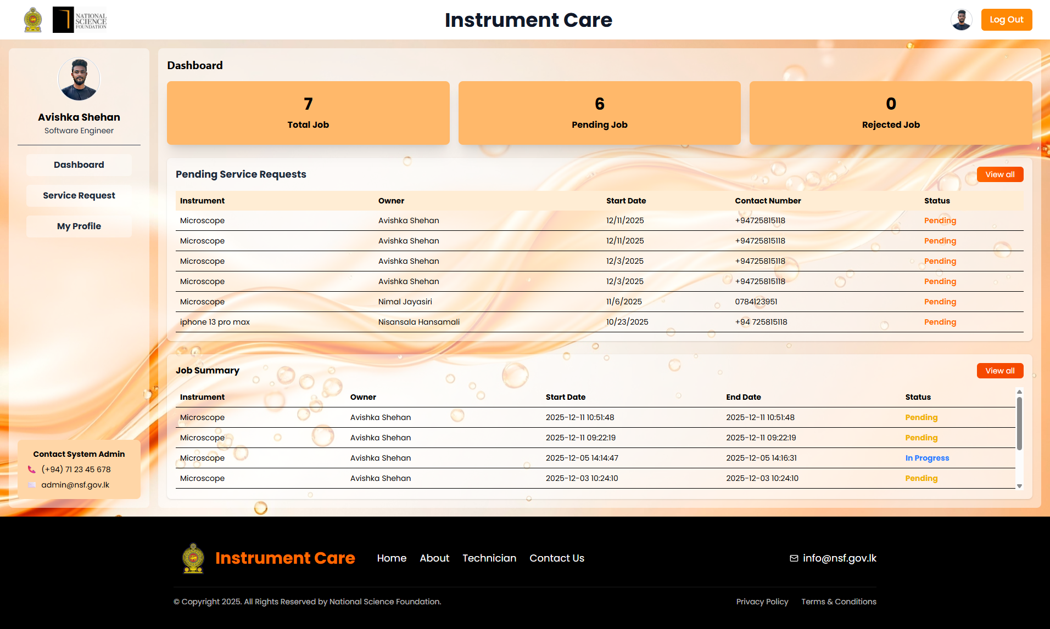
Figure 5 — The Technician Dashboard. The status badge at the top of the sidebar is your quickest progress check.

9. Step 7 — Start Working on Requests
Once the badge turns green, the system starts matching service requests to you based on the technical expertise, service coverage and availability you declared in your profile. Use the sidebar to navigate.

Dashboard
Your overview: summary statistics for your activity, the service requests assigned or matched to you, and a job summary of completed work.

Service Request
The list of service requests you can act on. Open a request to see the full details, then choose to respond.
Action | What happens
Accept | Opens a response form. Fill in the Client Email Address, a Subject and a Message, then press Send Acceptance. The owner is notified by email immediately. Press Back to return to the list without sending.
Decline | Opens a similar form where you give a reason for declining. The response is recorded and the owner is notified.
View | Opens the request details panel so you can read the full job description before deciding.

Two further pages keep a full history: All Service Request (every request, searchable by reference, client or instrument) and All Job Summary (your job records, also searchable). Use them to check on the status of anything you have already responded to.
All Service Request | All Job Summary | Keeping Your Profile Current
Complete list of requests  Search by reference ID, client name or instrument  Filter by date range | Your job records  Searchable record list  Use for reference and audit purposes | Add new certificates as you earn them  Update employment when you move roles  Re-accept terms if they are revised  Keep expiry dates accurate

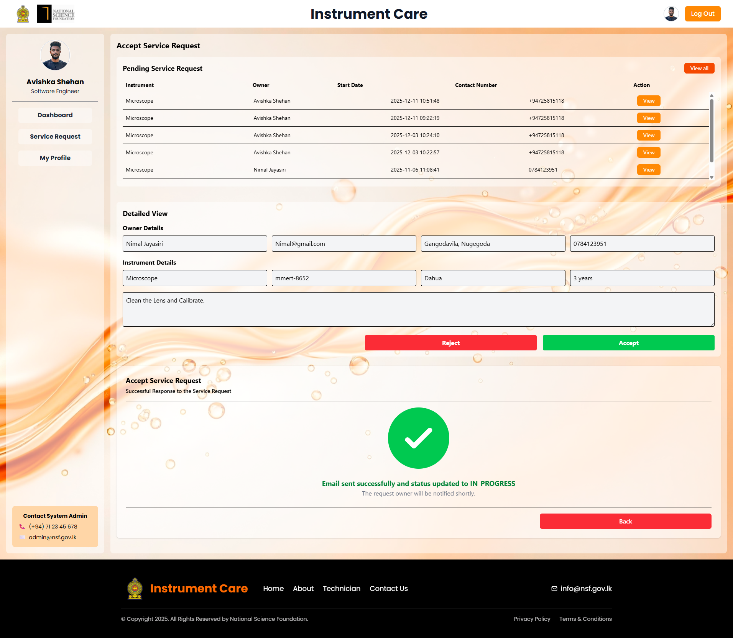
Figure 6 — Responding to a service request. Fill in the client email, subject and message, then send.
Professional reminder
You accepted a term to maintain a complete record of all maintenance, repair and calibration work for audit purposes. Keep the profile and job records accurate — they are the audit trail.

10. Troubleshooting & Common Errors
Message or symptom | What it means and how to fix it
“Please complete all required fields (see highlighted sections) before submitting.” | A required field in Personal Information is empty. Check the red Needs attention badges.
“Please select an institute from the suggestions” | You typed the institute name but did not click it in the suggestion list. The name must match a record in the system.
“Enter a valid NIC (9 digits + V/X or 12 digits)” | Check the NIC format — either 9 digits then V or X, or 12 digits.
“Mobile number must be 10 digits starting with 0” | Use the local format 0771234567 — no spaces, no plus sign, no country code.
“Add at least one technical expertise entry.” | Add at least one laboratory category, instrument category, instrument or care category.
“Add at least one certificate.” | Add at least one certificate with a name and number.
“Add at least one current/past employment entry.” | Add at least one employment entry with organization, position and start date.
“Please accept all 4 terms” | Tick all four Terms and Conditions checkboxes. This is what moves you to Submitted.
“Save or cancel the current edit before submitting.” | You left a row open in the editor. Press Save or Cancel on that row first.
“The form has missing or invalid fields. Please fix the highlighted sections.” | The red summary box lists exactly which sections are blocked — click a section name to jump to it.
Sidebar stuck on Awaiting Supervisor Confirmation | Your supervisor has not opened the consent link yet. Use Resend Invitation, and check that you entered their current email address.
Status still Not Approved after submitting | You are in the review queue. If a supervisor was declared, consent is the usual blocker. Otherwise contact the System Administrator.
Profile marked Declined | Correct the problem in My Profile and re-submit. Do not register a new account.
“Email could not be sent. Please contact support.” | The supervisor invitation email bounced. Verify the address and resend, or contact the administrator.

Contact System Administrator
Phone: +94 (0)11 2 696771 Extension: 191, 126
Email: nid@nsf.gov.lk

11. One-Page Final Checklist
Keep this page open while you work through the profile.

Account
☐ Registered using the Technician Registration form (not the general user form)
☐ Verified the 6-digit OTP sent to my email address
☐ Signed in successfully and reached the Technician Dashboard

Personal Information
☐ Title, Name with Initials, NIC, Gender, Address and District completed
☐ Mobile number is 10 digits starting with 0
☐ Institute question answered — institute selected from the suggestion list and designation filled in
☐ Supervisor question answered — if Yes, all four supervisor fields completed
☐ Supervisor consent link opened and consent recorded (badge is green, not amber)

Technical Profile
☐ Technical Expertise — laboratory categories, instrument categories, instruments and care categories added; any unlisted instruments added as manual overrides
☐ Areas of Technical Expertise — at least one service coverage and at least one availability option
☐ Current / Past Employment — at least one entry with organization, position and start date
☐ Certificates — at least one entry with certificate name and number, file scanned where possible
☐ Related Work Experience — completed if applicable (optional)
☐ All four Terms and Conditions accepted
☐ Submit Profile pressed and “Profile saved successfully!” seen

Approval & Go Live
☐ Status has moved from Pending to Submitted
☐ Administrator has reviewed the profile
☐ Sidebar badge shows green Approved
☐ Service requests can now be accepted and declined

